Student Checklist for Accessing Teams

Accessing Microsoft Teams with Computers using browsers (Chrome, Safari, Edge, Internet Explorer)
Open your internet browser on your computer (Chrome, Safari, Edge, Internet Explorer) | https://teams.microsoft.com
Then in the box that says “Sign in”, type in your login name which is: studentid@washoeschools.org  Then click Next.  *Note*: studentid = your own student id number | 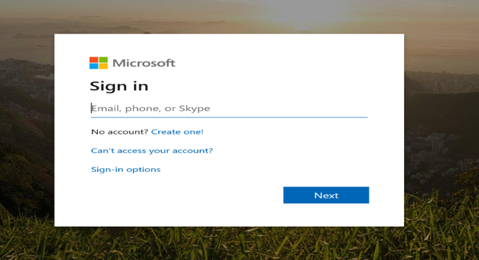
Click on “Work or school account.” | 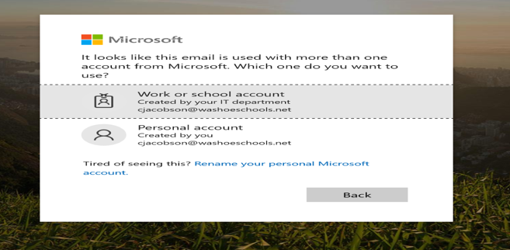
When the next box pops up type your password into the password box, then click Sign In.  **Note:** Your password is the same password you use to sign in to the computers at school. | 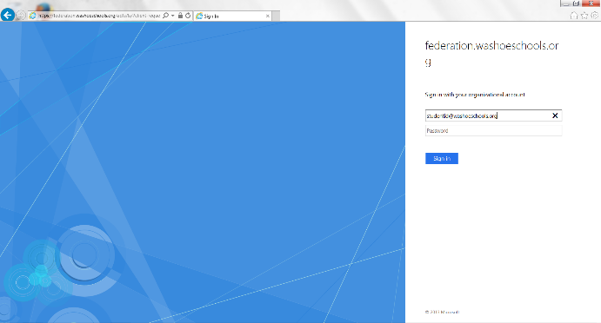
You will now see your Microsoft Teams listed down the left side of the screen. | 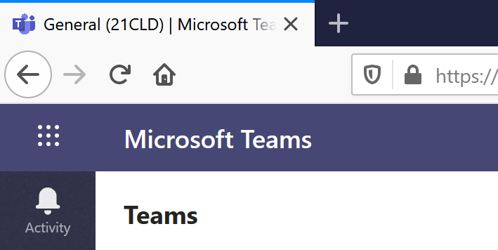
Choose the class Team you would like to go to. | 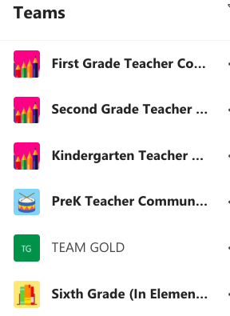
Across the top of the screen you will see Tabs next to the word “General” . Posts is where you will see announcements, assignments that may be posted, and conversations will show up here.
To join a meeting, go to your “Posts”. You will see a “Join” button. Click to join a meeting. | 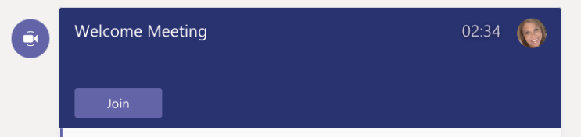
Across the top of this screen, you will also see a tab marked “assignments”. Click on this to get and turn in your assignment. | 

Accessing Microsft Teams on a Mobile Device (IOS/Android)
o
In order to access Microsoft Teams on a mobile device, you must download the Teams App.

Search the App Store for Microsoft
Teams. It is free to download.
Click “Sign In”
Sign-in address: You will need to use your student ID followed by @washoeschools.org for your username.
(Example: 1234567@washoeschools.org)

Password: Please contact your school for directions on your password

Hint: double check to make sure you’re using .org and not .net

When you first open Teams, the first screen you will see is Activity. Click on “Teams” at the bottom to see your classes.
Find the class you want and click on “General” to see the Posts, Files, Notebooks and Assignments for your class.
Within each of your class teams, you will see Posts, Files and More at the top of your screen. You can post a question to your teacher in the Posts by adding it in the “Type a new post” at the bottom of the screen. | 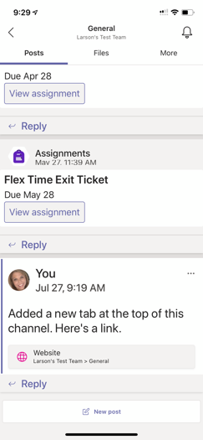
To join a meeting, If one is in progress, make sure you are in “Posts” Click on the “Join” button. | 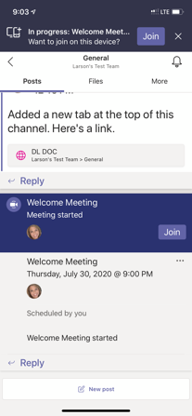
You can access your assignments by clicking on “More” at the top of the screen. | 